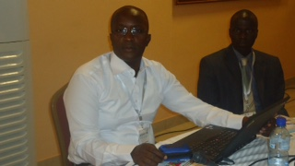

Mbalo THIOUNE
Secretary General IFCS Croix Rouge
Dear Ambassador, We really appreciate all you have done for 300 people during this Dakar / KM summer camp. You have supported us financially and also you have provided us with quality food to enable these people to live with dignity. Your gesture goes straight to our heart and we say thank you. A little word but very meaningful. We love you and tell those who support you, THANK YOU.

